Summer Internship Packet

New Mexico Public Education Department
College and Career Readiness Bureau
300 Don Gaspar, Santa Fe, NM 87501
Elaine Perea, PhD, Director | Elaine.Perea@state.nm.us
SUMMER INTERNSHIP AGREEMENT

County/Tribe/Pueblo: __________________________________________________________

The COUNTY/TRIBE/PUEBLO agrees to the following:
1. Provide a thorough orientation to the job and work-site
2. Provide a meaningful, well-supervised work experience
3. Provide evaluation of performance, time for consultation with, and on-site monitoring visits
4. Keep accurate attendance and/or time records
6. Consult the Intern Coordinator regarding problems related to the work experience
NOTE: NMPED must be contacted before considering suspension/transfer/termination
7. Conform to state and federal labor laws, and provide worker’s compensation coverage for paid interns.
8. Follow all rules of the program including all expectations and obligations set forth in the NMPED Summer Enrichment Internship Program RfA.

Intern Name: _____________________________ High School: ________________________

Start Date: ________________ End Date: ___________________ Hrs./Week: _____________

The Intern agrees to accept, and the Parent/Guardian agrees to support the following:
      - Regularly attend all days at the intern-site location.
      - Follow all rules of the Organization including all expectations and obligations set forth in the Summer Internship Packet, the Confidentiality Agreement, and any other agreements with NMPED related to the internship.
      - Notify the Mentor and Intern Coordinator prior to any absences.
      - Demonstrate honesty, punctuality, cooperation, proper grooming, and a willingness to learn.
      - Consult Intern Coordinator and Mentor about any problems that arise in the course of the internship.
      - Complete required employability workshops and furnish necessary information within Timesheet/Skills Grid and Mentor Feedback Reflections.
      - Transportation to and from the internship is the responsibility of the parent/guardian.
      - Understand that neither NMPED nor the Employer guarantees any particular outcome for the student as a result of the internship in terms of licensure or certification.
      - Understand that the student may be removed from the internship at the discretion of the Employer.
      - Students understand that this is a paid internship, and must complete the internship in order to receive full compensation.

Intern Signature: _________________________________ Date: ________________________

Parent/Guardian Signature: __________________________ Date: ________________________
MENTOR REPONSIBILITIES / LINES OF COMMUNICATION

MENTOR RESPONSIBILITIES

- Work with interns to coordinate work schedules
- Verify and sign student timesheet/skills grid weekly
- Evaluate intern performance via Google Survey every Thurs. OR Fri.
- Review progress with the intern periodically
- Provide an environment free from all types of harassment
- Support the missions of NMPED and Your Organization/Company: to enhance the health, safety and quality of life for all residents of the state of New Mexico
LINES OF COMMUNICATION
Mentor:
1. Intern Coordinator
2. Parent/Guardian
Intern:
- Mentor
- Intern Coordinator

- Contact Info: Name ______________________________, Intern Coordinator
  - Phone: _________________ Email: _______________________________
- Contact Info: Name ______________________________, Mentor
  - Phone: _________________ Email: _______________________________
- Parent/Guardian Emergency Contact Name and Phone: Note – DO NOT contact unless emergency.

_____________________________________ _________________________
Parent/Guardian (PRINT) Daytime Phone

_____________________________________ _________________________
Intern (PRINT) Phone Number

INTERN CONFIDENTIALITY AGREEMENT

As an intern placed in an internship, I understand that I may have access to confidential
information/data, which may include, but is not limited to, information/data relating to:
- Customers (such as records, conversations, financial information, etc.).
- Employees (such as wages, employment records, disciplinary actions, etc.).
- General or private information (such as financial and statistical records, internal reports, memos, communications, access codes, proprietary technology, etc.).
Accordingly, and as a condition of my participation as a student intern, I promise that:
- I will use confidential information/data only as needed by me to perform my legitimate duties as a student intern. This means, among other things, that:
- I will not access confidential information which I have no legitimate need to
know.
- I will not in any way divulge, copy, release, sell, loan, revise, alter, or destroy any
confidential information/data except as properly authorized.
- I will not misuse confidential information/data or deal carelessly with confidential
information/data.
- I understand that my obligations under this agreement will continue after termination of my status as a student intern.
- I will be responsible for my misuse or wrongful disclosure of confidential information/data, and for my failure to safeguard my access code or other information. I understand that my failure to comply with this agreement will result in the termination of my internship arrangement, and may also result in legal liability and other consequences.

AT ALL TIMES DURING MY INTERNSHIP, I WILL ACT IN THE BEST INTERESTS OF
THE BUSINESS WITH WHICH I AM PARTICIPATING AND IN COMPLIANCE WITH ALL LAWS.

Intern Signature: ______________________________________ Date: _________________
Parent Signature: ______________________________________ Date: ________________
INTERN RIDE-A-LONG AGREEMENT

Intern Name: ______________________________________________________
Please Print

Parent/Guardian of Intern:

The internship experience may require transportation as part of the internship.

- I understand that my child must wear a seat belt at all times.
- I understand that the driver is a licensed and insured adult.
- I understand that travel with the employer is an integral part of this internship experience and will help to provide a complete experience.

Please indicate by checking one of the following choices below:

I give permission for my child to “Ride-A-Long” as specified above.
Washington County School District Work Based Learning Student Name: ______________________________________________________ Please Print Parent/Guardian of Student Intern: The internship experience may require transportation as part of the internship. I understand that my child must wear a seat belt at all times. I understand that the driver is a licensed and insured adult. I understand that travel with the employer is an integral part of this internship experience and will help to provide a complete experience. I understand that my child will never travel alone in a vehicle with the employer sponsor. or another adult. Please indicate by checking one of the following choices below: I give permission for my child to “Ride-A-Long” as specified above. I do not give permission for my child to “Ride-A-Long” with their employer during the internship experience. __________________________________________ _______________________ Parent/Guardian Date __________________________________________ _______________________ Parent/Guardian (Please Print) Day time phone #

I do not give permission for my child to “Ride-A-Long” with their employer during the
Washington County School District Work Based Learning Student Name: ______________________________________________________ Please Print Parent/Guardian of Student Intern: The internship experience may require transportation as part of the internship. I understand that my child must wear a seat belt at all times. I understand that the driver is a licensed and insured adult. I understand that travel with the employer is an integral part of this internship experience and will help to provide a complete experience. I understand that my child will never travel alone in a vehicle with the employer sponsor. or another adult. Please indicate by checking one of the following choices below: I give permission for my child to “Ride-A-Long” as specified above. I do not give permission for my child to “Ride-A-Long” with their employer during the internship experience. __________________________________________ _______________________ Parent/Guardian Date __________________________________________ _______________________ Parent/Guardian (Please Print) Day time phone #

internship experience.

__________________________________________ _____________________
Parent/Legal Guardian Signature Date

__________________________________________ _____________________
Parent/Legal Guardian (Print) Date

__________________________________________ _____________________
Intern Signature if 18 or older Date

RULES OF THE INTERNSHIP

DON’T | DO
- Come into work late | - Arrive early every day
- Call into work for same day absence | - Do let your mentor know ahead of time
- Not show up for work without notice | - Call into work to let them know you cannot make it (legit reason)
- Go on 1 week family vacation during your internship | - Plan with your mentor when you need time off
- Lie, steal, or be disrespectful | - Be honest and respectful
- Fight, substance abuse | - Self-control
- Dress inappropriately | - Dress appropriate for worksite
- Keep a problem or concern to yourself | - Communicate with your WBL Coordinator about a problem or concern
- Bring your negative emotions into the workplace | - Have a positive attitude
- Get on your phone during downtime | - Find a way to be productive
- Breach confidentiality | - Keep confidentiality
- Overstep your boundaries | - Think twice before you act
- Be afraid to make mistakes | - Try your best, positive results will come!
- Try to wing it if you don’t understand | - Ask questions to gain a better understanding of tasks assigned
- Ask your mentor to do your timesheet | - Your timesheet first, ask mentor to sign or initial only
- Take random photos and blast them on social media | - Ask your mentor to take a photo/video of you working hands-on

IMPORTANT

CONFORM TO RULES, REGULATIONS, AND SAFETY STANDARDS OF THE WORK-SITE AND MAINTAIN CONFIDENTIALITY

SUMMER INTERNSHIP PROCESS

BEFORE
Attend Summer Internship Orientation

DURING
Summer Internship:
- Monday’s: Attend/Participate in Employability Workshops w/ Intern Coordinator (Don’t forget your internship packet!)
  - Reflection: Mentor Feedback for Intern – 1x Week
  - Timesheets are DUE – 1x Week OR Bi-Weekly
- Tues.-Fri: 15-20 hours at Work-site – 2-4x Week
- Tues.-Fri: Timesheets/Skills Grid** – 2-4x Week
**Note: It is intern’s responsibility to fill out their timesheet/skills grid, daily. Mentor’s will verify and initial at end of week.
SUMMER INTERNSHIP TIMESHEET & SKILLS GRID
Intern Name: _________________________ School: __________________________________
Intern-Site: ___________________________ Internship Position: ________________________
Directions: Complete form with your intern-site Mentor and submit to Intern Coordinator
Due dates: Bi-Weekly
WEEK

1
Date: | Hours: | Mentor Initials: | Specific Job Skills: List the new skills and/or duties you obtained during this day. Be specific.
06/21/2021 | 3.5 |  | Example: Observed different departments in the company/organization and learned how they earn a profit.
WEEK

2

Total Hours: _______________

Intern Signature: _____________________ Intern Coordinator Signature: _________________________

SUMMER INTERNSHIP TIMESHEET & SKILLS GRID
Intern Name: _________________________ School: __________________________________
Intern-Site: ___________________________ Internship Position: ________________________
Directions: Complete form with your intern-site Mentor and submit to Intern Coordinator
Due dates: Bi-Weekly
WEEK

3
Date: | Hours: | Mentor Initials: | Specific Job Skills: List the new skills and/or duties you obtained during this day. Be specific.
07/05/2021 | 3.25 |  | Example: Learned how to input data on company database system and problem solved on how to deal with an upset customer.
WEEK

4

Total Hours: _______________

Intern Signature: _____________________ Intern Coordinator Signature: _________________________

SUMMER INTERNSHIP TIMESHEET & SKILLS GRID
Intern Name: _________________________ School: __________________________________
Intern-Site: ___________________________ Internship Position: ________________________
Directions: Complete form with your intern-site Mentor and submit to Intern Coordinator
Due dates: Bi-Weekly
WEEK

5
Date: | Hours: | Mentor Initials: | Specific Job Skills: List the new skills and/or duties you obtained during this day. Be specific.
07/19/2021 | 3.75 |  | Example: Presented idea to company stakeholders on how to better engage younger customers.
WEEK

6

Total Hours: _______________

Intern Signature: _____________________ Intern Coordinator Signature: _________________________

Summer Internships: Mentor Evaluation Reflection
SUMMER INTERNSHIPS: MENTOR FEEDBACK REFLECTION

INSTRUCTIONS:
Interns, rate yourself from 1-10 on how you think you scored in each respective row during your internship last week. Next, you will receive your Mentor’s Feedback with your actual scores. Reflect on how you believe you can improve. Share out if appropriate.

1 = Below Expectations | 10 = Exceeded Expectations
 | Intern Response Score | Mentor Response Score
Work Habits & Attitudes
Interpersonal Effectiveness
Technical Skills

Quality of Work Accomplished
Dependability

Communication Competencies
Mathematical & Problem-Solving Competencies
Appearance & Grooming
- Are your scores close to your mentor score? Why or why not? Surprises?

- What can you do to improve your lower scores?

Summer Internships: Mentor Evaluation Reflection
SUMMER INTERNSHIPS: MENTOR FEEDBACK REFLECTION

INSTRUCTIONS:
Interns, rate yourself from 1-10 on how you think you scored in each respective row during your internship last week. Next, you will receive your Mentor’s Feedback with your actual scores. Reflect on how you believe you can improve. Share out if appropriate.

1 = Below Expectations | 10 = Exceeded Expectations
 | Intern Response Score | Mentor Response Score
Work Habits & Attitudes
Interpersonal Effectiveness
Technical Skills

Quality of Work Accomplished
Dependability

Communication Competencies
Mathematical & Problem-Solving Competencies
Appearance & Grooming
- Are your scores close to your mentor score? Why or why not? Surprises?

- What can you do to improve your lower scores?

Summer Internships: Mentor Evaluation Reflection
SUMMER INTERNSHIPS: MENTOR FEEDBACK REFLECTION

INSTRUCTIONS:
Interns, rate yourself from 1-10 on how you think you scored in each respective row during your internship last week. Next, you will receive your Mentor’s Feedback with your actual scores. Reflect on how you believe you can improve. Share out if appropriate.

1 = Below Expectations | 10 = Exceeded Expectations
 | Intern Response Score | Mentor Response Score
Work Habits & Attitudes
Interpersonal Effectiveness
Technical Skills

Quality of Work Accomplished
Dependability

Communication Competencies
Mathematical & Problem-Solving Competencies
Appearance & Grooming
- Are your scores close to your mentor score? Why or why not? Surprises?

- What can you do to improve your lower scores?

Summer Internships: Mentor Evaluation Reflection
SUMMER INTERNSHIPS: MENTOR FEEDBACK REFLECTION

INSTRUCTIONS:
Interns, rate yourself from 1-10 on how you think you scored in each respective row during your internship last week. Next, you will receive your Mentor’s Feedback with your actual scores. Reflect on how you believe you can improve. Share out if appropriate.

1 = Below Expectations | 10 = Exceeded Expectations
 | Intern Response Score | Mentor Response Score
Work Habits & Attitudes
Interpersonal Effectiveness
Technical Skills

Quality of Work Accomplished
Dependability

Communication Competencies
Mathematical & Problem-Solving Competencies
Appearance & Grooming
- Are your scores close to your mentor score? Why or why not? Surprises?

- What can you do to improve your lower scores?

Summer Internships: Mentor Evaluation Reflection
SUMMER INTERNSHIPS: MENTOR FEEDBACK REFLECTION

INSTRUCTIONS:
Interns, rate yourself from 1-10 on how you think you scored in each respective row during your internship last week. Next, you will receive your Mentor’s Feedback with your actual scores. Reflect on how you believe you can improve. Share out if appropriate.

1 = Below Expectations | 10 = Exceeded Expectations
 | Intern Response Score | Mentor Response Score
Work Habits & Attitudes
Interpersonal Effectiveness
Technical Skills

Quality of Work Accomplished
Dependability

Communication Competencies
Mathematical & Problem-Solving Competencies
Appearance & Grooming
- Are your scores close to your mentor score? Why or why not? Surprises?

- What can you do to improve your lower scores?

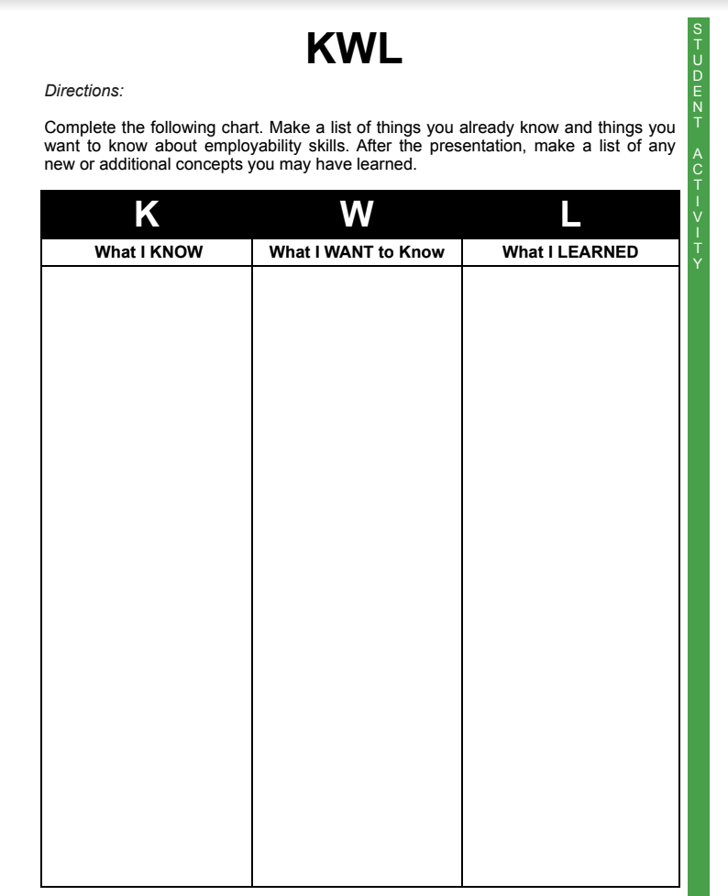

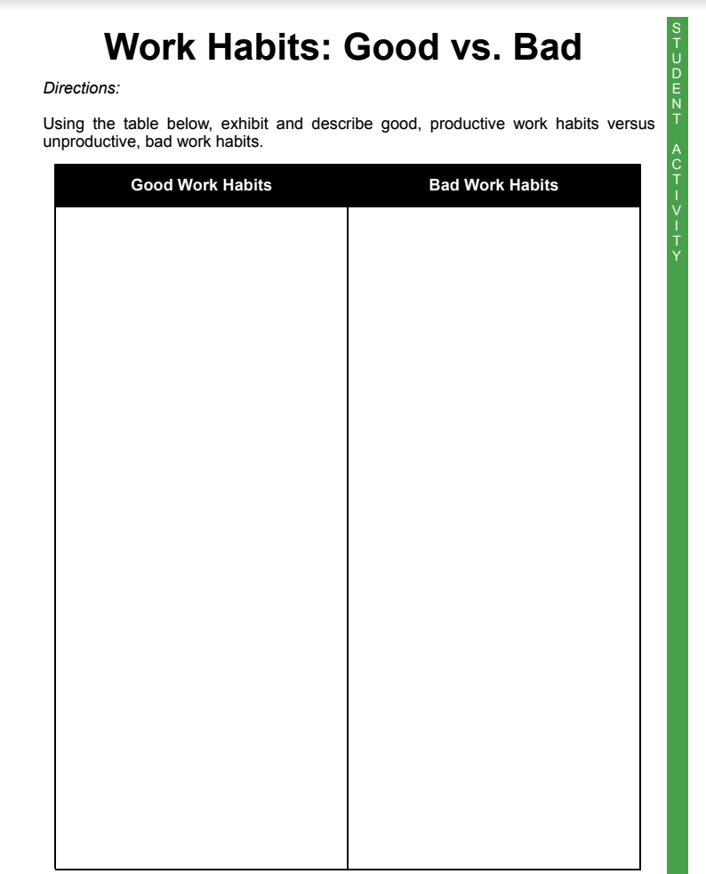

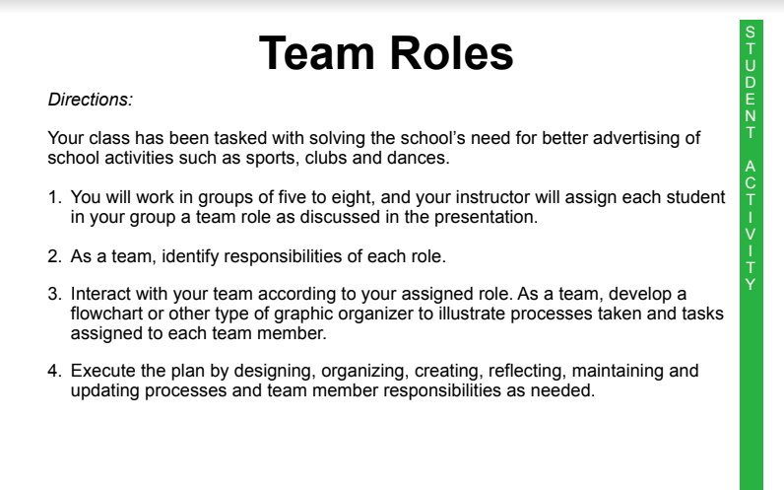

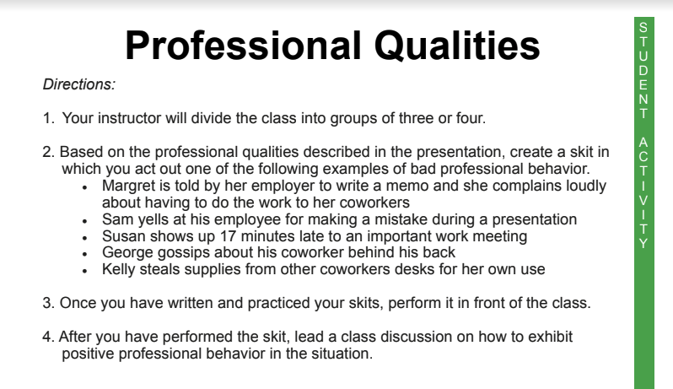

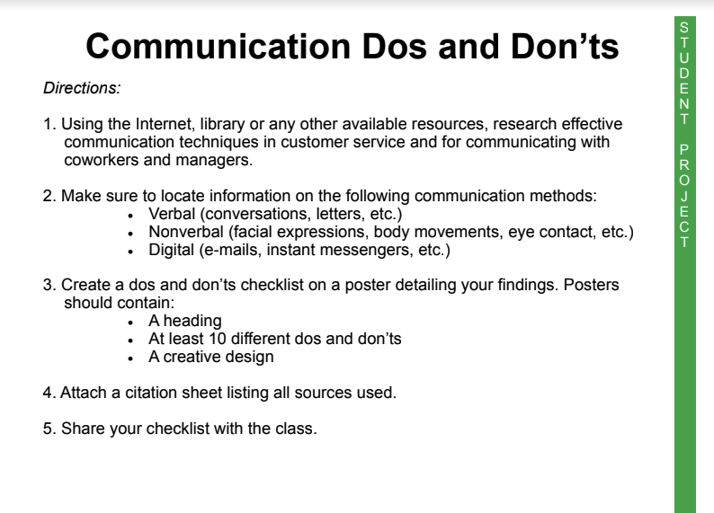

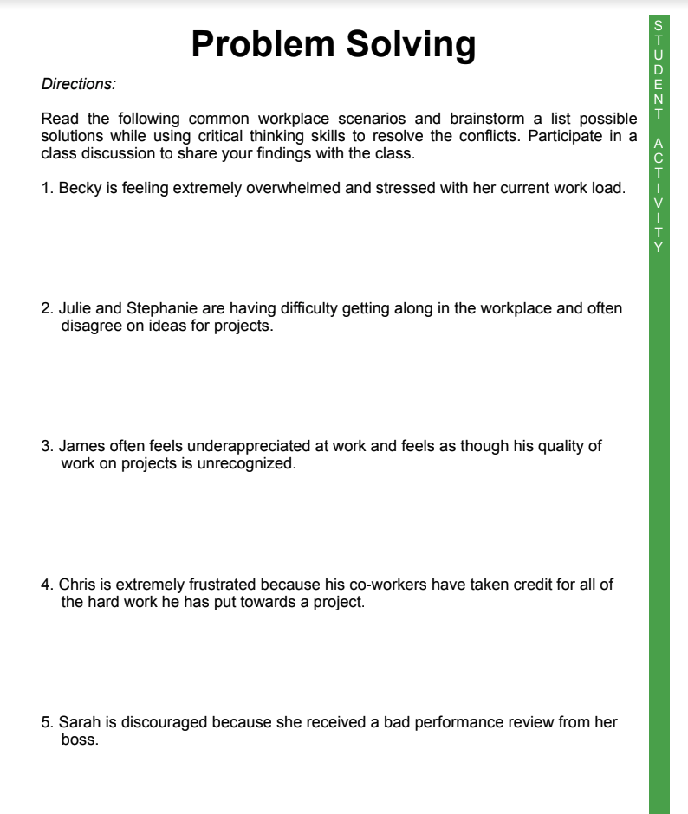

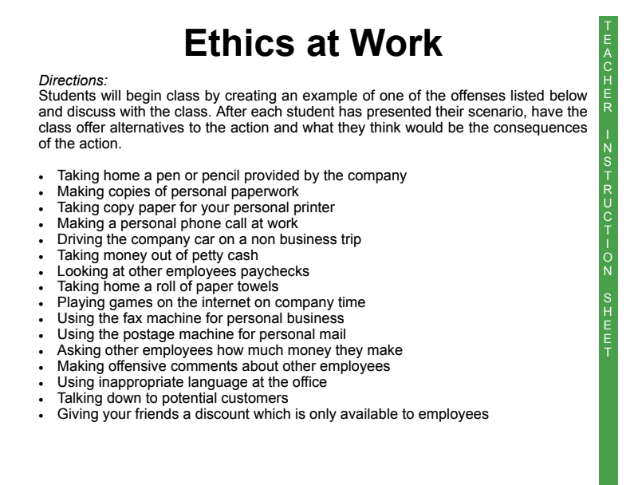

STUDENT QUESTIONS FOR MENTORS - ON THE JOB
Internships can be extremely valuable, so make sure you use your time there wisely.
General Career Exploration
      - How did you decide on this career?
      - How does this career fit your interests, values, and skills?
      - What skills are most important for success?
      - What kind of person does well in this industry/company?
      - What are your main duties?
      - What skills do you use most in your position?
      - What is the normal background for someone in your role?
      - What is a typical day for you in your position?
      - What class did you take that was the most helpful for your career?
Stories
      - How did you land your current role?
      - Think back five years ago. Did you envision this is where you would be?
      - Can you tell me about a time when you had a difficult boss? How did you handle it?
      - How did you learn to embrace failure?
      - What’s the most important leadership lesson you’ve learned and how is it valuable?
      - Was there a job position that you applied for and got, but you weren’t 100% qualified?
      - How did you build the skill of always speaking so engagingly in front of others?
Specific to Organization
      - How would you characterize the work culture/environment in this setting?
      - Can you share with me the structure of the department or division and how it fits into the total organization?
      - What do you like most/least about working for this company?
Specific to Industry
      - How did your time at ‘OCU’ (inside or outside the classroom) prepare you?
      - What are some of the challenges?
      - What experiences should I engage in to be better prepared?
      - How is this field/industry changing?
      - What are some typical entry level jobs?
      - How do you work your way up in this industry?
      - What are some job search strategies you recommend?
Self-Awareness
      - What are three skills I need to improve?
      - What things should I pay more attention to?
      - Where do you see my strengths and what should I focus on to improve?
      - How am I viewed (i.e., what is my personal brand) in our organization?
      - How can I communicate more clearly?
      - What can I do to make You more successful today?

